DATE | 20-02-2026
TEAM ID | LTVIP2026TMIDS90622
PROJECT NAME | SMART SORTING : TRANSFER LEARNING FOR IDENTIFYING ROTTEN FRUITS AND VEGETABLES
MAXIMUM MARKS | 4 MARKS

6.5 APPLICATION BUILDING
In this section, we will be building a web application that is integrated into the model we built. A UI is provided for the uses where he has to enter the values for predictions. The enter values are given to the saved model and prediction is showcased on the UI.
This section has the following tasks
- Building HTML Pages
- Building server-side script
Building HTML Pages:
For this project create two HTML files namely
- index.html
- Portfolio-details.html
And save them in the templates folder.

- Style.css(in static =>css => style.css)
- Image(in static => image=>img.jpg)
UI Image preview:
This html pages and css spreadsheet will help to enhance the beauty of our web page “Neutrigaze”.
It provide home page and predict page in the preview as shown in the image given below .

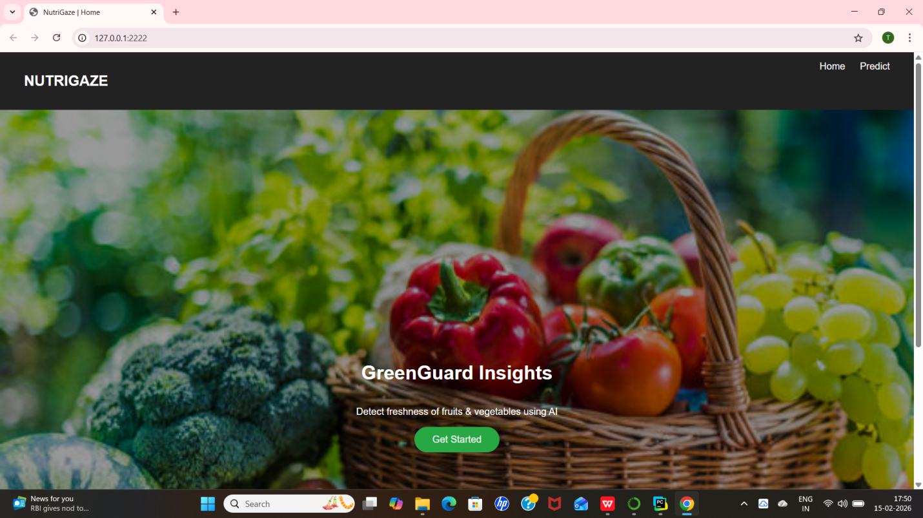
Now when you click on the predict button further in the top right corner you will get redirected to portfolio-details.html
Let’s look at what our inner.html file looks like and test the model:
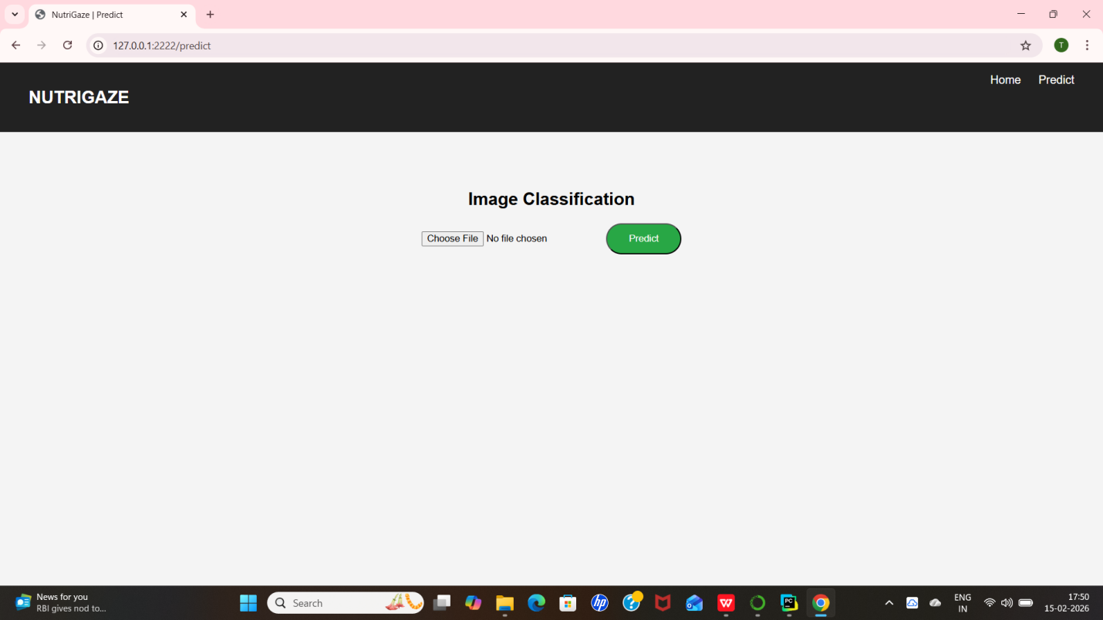
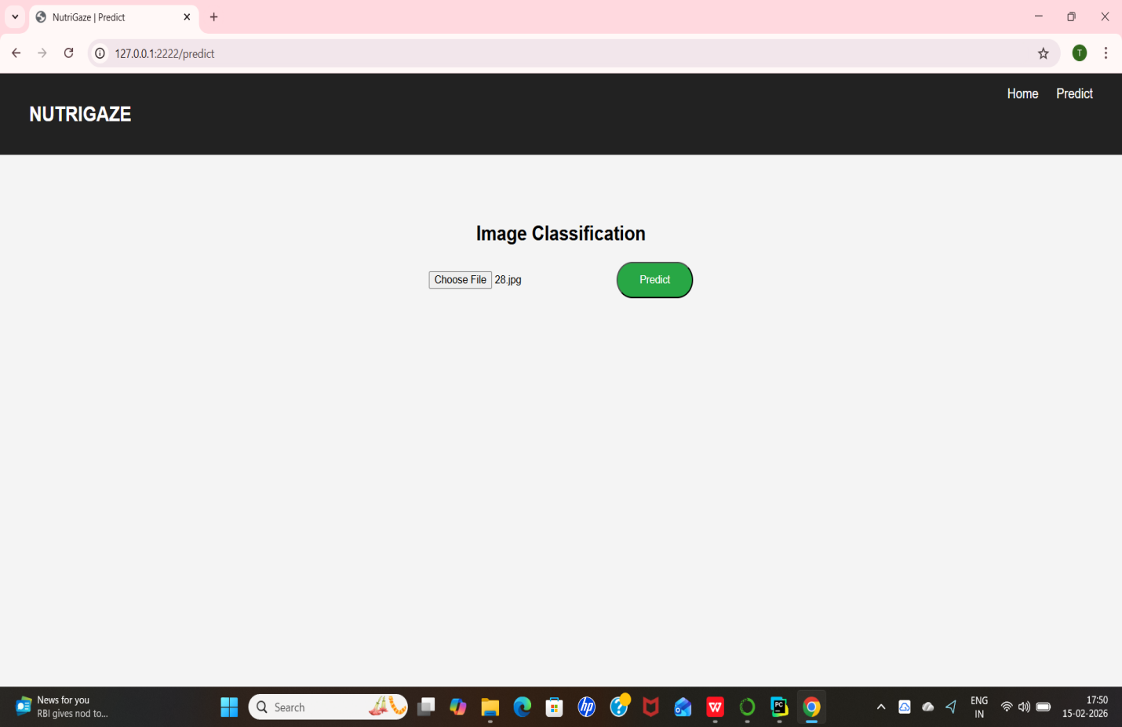
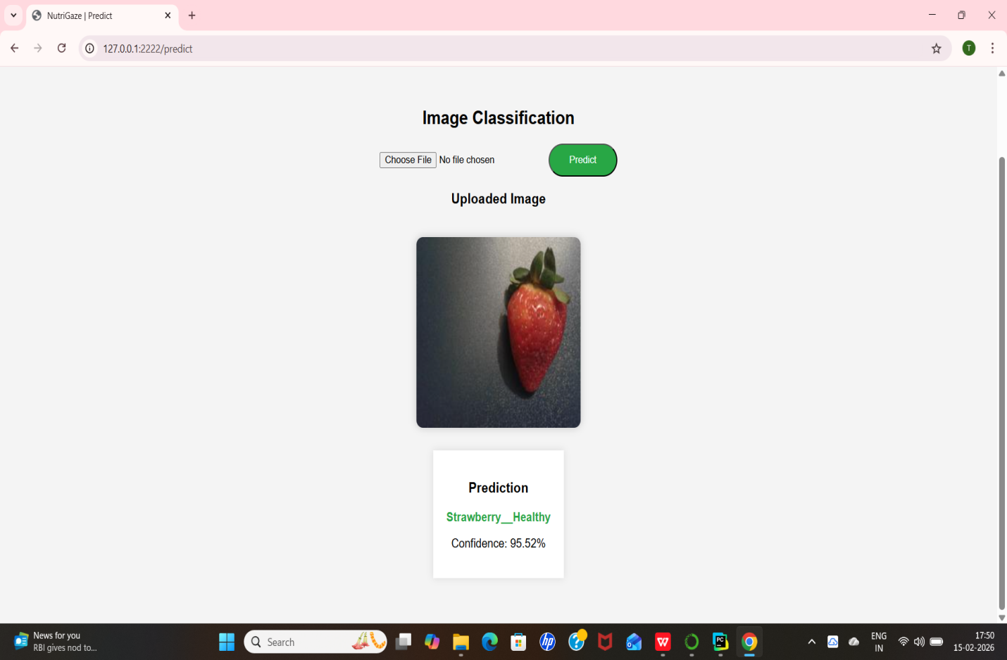
Test Class rotten cucumber (8):
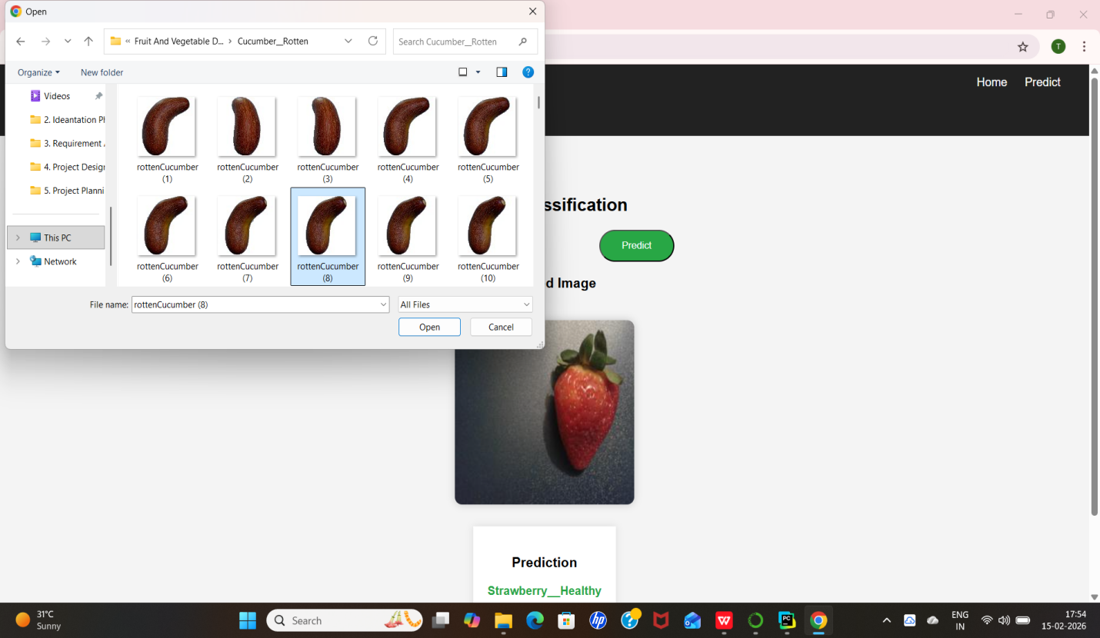
Now when you click on predict button you will get output down to the image itself.Let’s look how our output looks like:
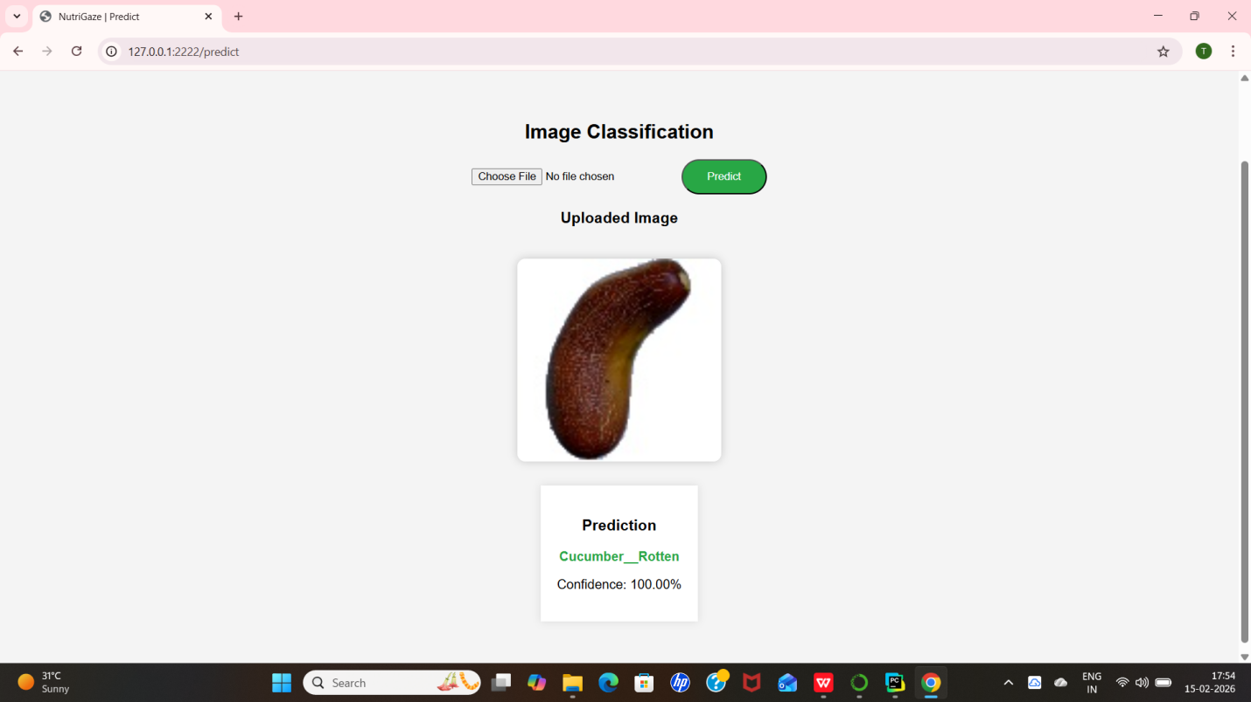
Build Python code:
Import the libraries
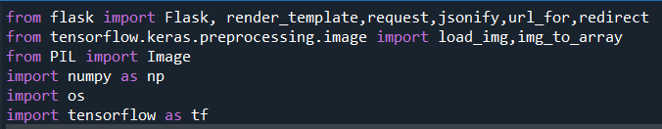
Load the saved model. Importing the Flask module in the project is mandatory. An object of the Flask class is our WSGI application. The Flask constructor takes the name of the current module (__name__) as argument.
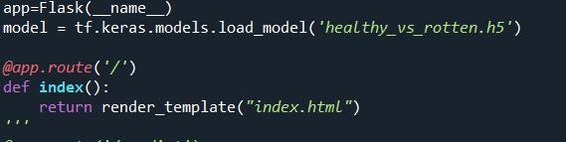
Here we will be using the declared constructor to route to the HTML page which we have created earlier.
In the above example, the ‘/’ URL is bound with the index.html function. Hence, when the index page of the web server is opened in the browser, the html page will be rendered. Whenever you enter the values from the html page the values can be retrieved using POST Method.
Retrieves the value from UI:
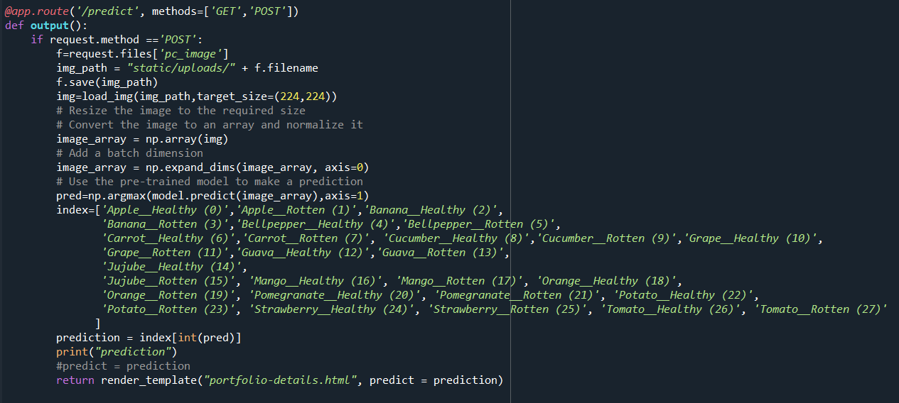
Here we are routing our app to the output() function. This function retrieves all the values from the HTML page using a Post request. That is stored in an array. This array is passed to the model. Predict () function. This function returns the prediction. This prediction value will rendered to the text that we have mentioned in the output.html page earlier.
Main Function:
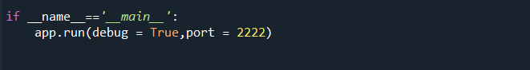

Run the web application
- Open Anaconda prompt from the start menu
- Navigate to the folder where your Python script is.
- Now type the “app.py” command
- Navigate to the local host where you can view your web page.
- Click on the inspect button from the top right corner, enter the inputs, click on the predict button, and see the result/prediction on the web.
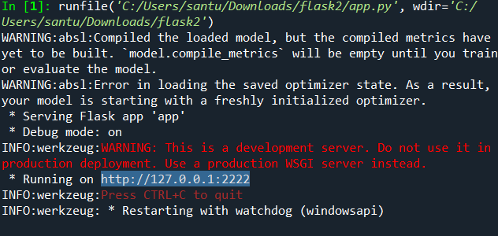TEST.PY CODE:
from flask import Flask, render_template, request
from tensorflow.keras.preprocessing.image import load_img, img_to_array
import numpy as np
import tensorflow as tf
import os
app = Flask(__name__)
# Load trained model
model = tf.keras.models.load_model("healthy_vs_rotten.h5")
# Threshold: If confidence is below 80%, we say "Out of Dataset"
# Adjust this (0.0 to 1.0) based on your testing!
CONFIDENCE_THRESHOLD = 0.92 # Requires 92% certainty
classes = [
'Apple__Healthy', 'Apple__Rotten', 'Banana__Healthy', 'Banana__Rotten',
'Bellpepper__Healthy', 'Bellpepper__Rotten', 'Carrot__Healthy', 'Carrot__Rotten',
'Cucumber__Healthy', 'Cucumber__Rotten', 'Grape__Healthy', 'Grape__Rotten',
'Guava__Healthy', 'Guava__Rotten', 'Jujube__Healthy', 'Jujube__Rotten',
'Mango__Healthy', 'Mango__Rotten', 'Orange__Healthy', 'Orange__Rotten',
'Pomegranate__Healthy', 'Pomegranate__Rotten', 'Potato__Healthy', 'Potato__Rotten',
'Strawberry__Healthy', 'Strawberry__Rotten', 'Tomato__Healthy', 'Tomato__Rotten'
]
@app.route("/")
def home():
return render_template("index.html")
from tensorflow.keras.applications.vgg16 import preprocess_input # Add this import
@app.route("/predict", methods=["GET", "POST"])
def predict():
prediction = None
confidence = None
image_path = None
filename = None
if request.method == "POST":
file = request.files.get("pc_image")
if file:
filename = file.filename
image_path = os.path.join("static/uploads", filename)
os.makedirs("static/uploads", exist_ok=True)
file.save(image_path)
# ✅ 1. Standard VGG16 Preprocessing
img = load_img(image_path, target_size=(224, 224))
img_array = np.array(img)
# If you used rescale=1/255 in training, keep the next line.
# If not, comment it out and use preprocess_input(img_array)
img_array = img_array / 255.0
img_array = np.expand_dims(img_array, axis=0)
# ✅ 2. Get All Probabilities
probs = model.predict(img_array)[0]
class_index = np.argmax(probs)
max_prob = probs[class_index]
# ✅ 3. Calculate "Confusion" (Gap between top 2 guesses)
sorted_probs = np.sort(probs)
top_choice = sorted_probs[-1]
second_choice = sorted_probs[-2]
gap = top_choice - second_choice
# ✅ 4. STRICT FILTERING
# A tiger shouldn't have a high gap, and its confidence shouldn't be massive.
# We require at least 85% confidence AND a 40% gap over the next best guess.
if top_choice < 0.85 or gap < 0.40:
prediction = "Out of Dataset"
confidence = top_choice * 100
else:
prediction = classes[class_index]
confidence = top_choice * 100
return render_template("portfolio-details.html", predict=prediction,
confidence=confidence, image_path=filename)
if __name__ == "__main__":
app.run(debug=True, port=2222)

